Big Mountain Resort Pricing Models
An analysis of 4 different scenarios to justify an increase in ticket pricing

Max Sussman
09/01/2023

INTRODUCTION
Big Mountain Resort in Montana which offers over 100 named trails in addition to bowl and ski skiing. These trails are serviced by 12 lifts,2 T-bars and a magic carpet. The most recent lift to have been added to help to better distribute patrons across the mountain more effectively. The operating costs of the resort have been increased by $1,540,000 and would like to offset this increase by increasing their profit by over 9% by the end of the season.

DATA CLEANING AND ANALYSIS
We have been given a database with 330 resorts within each state that have been deemed to be of the same market share. We started out by removing any columns with missing values and further determined which columns we could drop for having little to no influence over ticket pricing. You have determined to not treat a resorts state as a factor since Big Mountain resort was the middle of the pack, with that determined we set up a heatmap of all the pertinent features of a resort and any correlations between them.
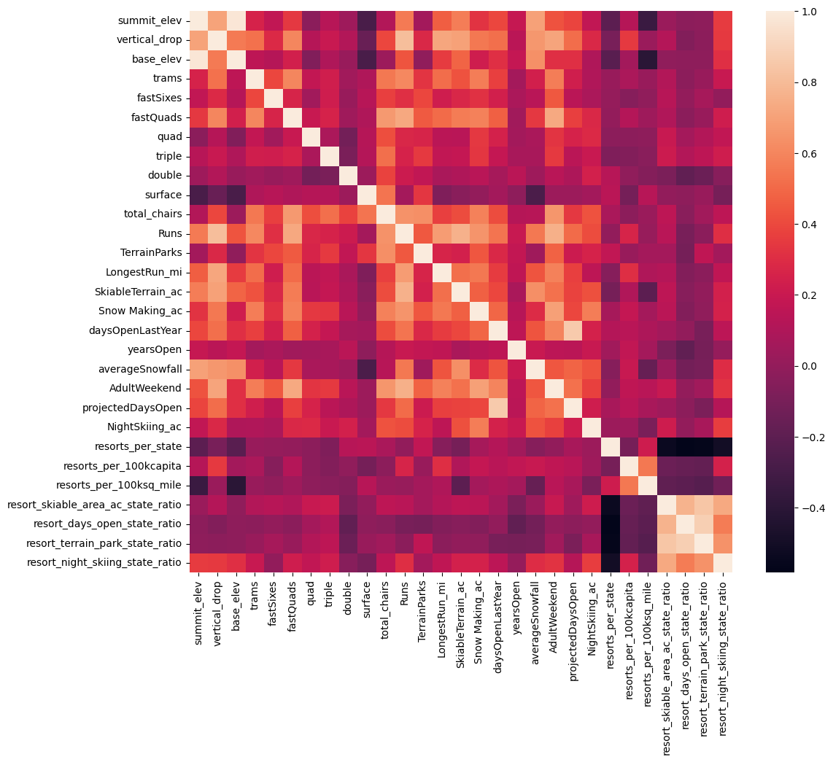

MODELING SCENARIOS
For our baseline pricing data we simply took the mean of all resorts ticket prices and compared that to actual current pricing data. In Montana there was little difference between Weekday and Weekend ticket prices, since there were fewer missing values in the Weekend ticket prices we are using that as our value of interest. The mean ticket price is $63.81, which is over $19 off from the actual. We imputed missing values using the median ticket price and then utilized a simple linear regression and random forest regression to determine that the random forest model has a lower cross-validation mean absolute error by almost $1. It also exhibits less variability. Verifying performance on the test set produces performance consistent with the cross-validation results. We then tested 4 different scenarios to assess which actions should be taken to increase yearly profits.
-Scenario 1 was to close up to 10 runs permanently. Closing 1 run does nothing, closing 2-5 runs would increase revenue, however closing between 6-10 runs hurts the ability to charge more.
-Scenario 2 was adding a run, increasing the vertical drop by 150 feet, and installing an additional chair lift. This scenario increases support for ticket price by $1.99. Over the season, this could be expected to amount to $3474638
-Scenario 3 is the same as scenario 2 with an added increase in snowmaking coverage of 2 acres. This scenario shows the exact same results as scenario 2, the small increase in snowmaking makes no difference.
-Scenario 4 calls for increasing the longest run by .2 miles and guaranteeing its snow coverage by adding 4 acres of snow making capability. Since the model we used weighs longest run so little this made no difference on ticket price.

CONCLUSION
Big Mountain Resort modelled price is $95.87, actual price is $81.00. Even with the expected mean absolute error of $10.39, this suggests there is room for an increase. I would suggest implementing scenarios 1 and 2. Further work should be done to see which runs are used the least to determine which runs to close which would affect the smallest number of patrons.

